Building initramfs image for Raspberry pi 3

Buildroot – the ultimate Linux book
Buildroot is a great Linux book for me.
It has almost everything we need to know about Linux.
It unite almost everything about Linux and the only thing we need to do is to follow every checkbox and understand what there is beyond.

I wanted to build a minimized image with initram fs only.
This is a getting started before I will build a LFS ( Linux from scrach) and actually do the same
manually as buildroot do it automatically.

Buildroot can build a cpio file , configure the kernel to use initramfs,

This is only an exercise, we don't need really need to work only in initram fs in the kernel with raspberry pi 3 and the booting speed is not really an issue.

The idea is to create fast and small file system on the ram,
The second partition will be use for all persistence data.

Many of the steps at the end was done manually , prepare the sdcard folder( on ubunto) and copy to the sdcard itself.

We start with a 32 bit raspberry pi 3
make raspberry3_defconfig

We go to file systems:

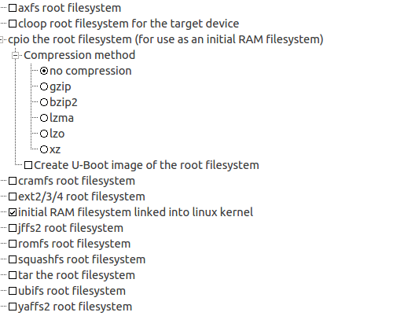
remove the ext 4 and check initial fam file system linked into the kernel.

Buildroot will configure the kernel with a CPIO file , no compress

type make linux-menuconfig after the make complete to see what buildroot configure in the kernel.

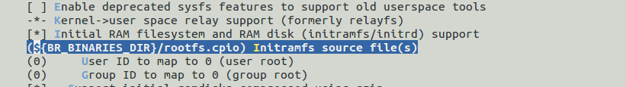
and we see that buildroot configure the kernel for a initramfs cpio source file:

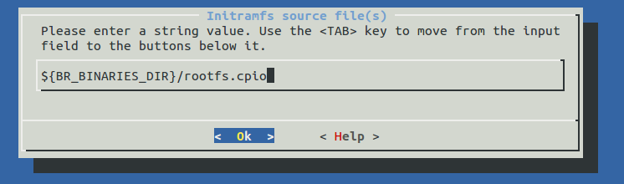

In order to understand better what should be placed in the initram fs image version
we can compare the content to a buildroot complete image with rootfs.

Raspberry pi 3 SD card content:

The following is the content of the sdcard from buildroot build:
The document will explain what is each file , how is generated
and will compare the content of the boot file to the content of the compilation of the raspberry pi 3 kernel as a stand alone build.

The boot – fat 32 ( or 16)

bcm2710-rpi-3-b.dtb
bcm2710-rpi-cm3.dtb
bootcode.bin
cmdline.txt
config.txt
fixup.dat
start.elf
zImage

Directory:
overlays

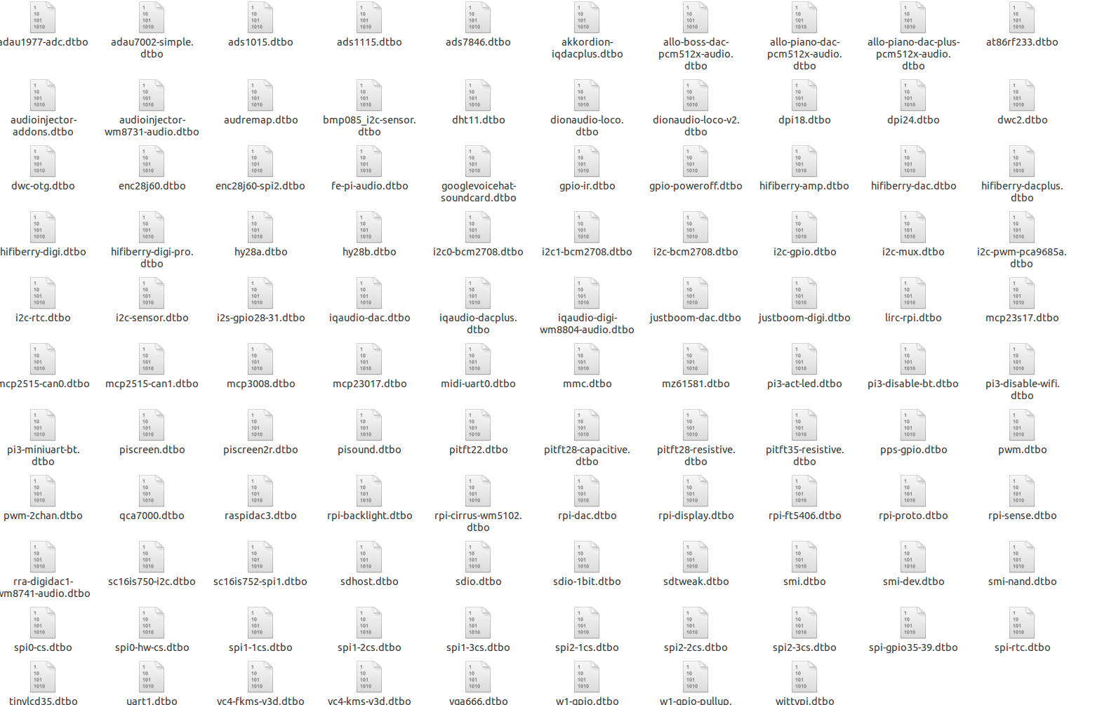

Raspberry pi 3 SD card content for initramfs only

bcm2710-rpi-3-b.dtb
bcm2710-rpi-cm3.dtb
rootfs.cpio
rpi-firmware zImage

genimage is currently failed because it designed to run with the full file system sd card.
We need to build only a boot partition.

The rpi-firmware directory contains the following files:

bootcode.bin cmdline.txt config.txt fixup.dat overlays start.elf

bootcode.bin , start.elf are the GPU firmware for the raspberry pi 3.

cmdline.txt , the kernerl command line parameters:
root=/dev/mmcblk0p2 rootwait console=tty1 console=ttyAMA0,115200

So for start , I created an sd card folder and copied all the boo files there.
Note that the rpi-firmware directory should be on the root of that folder.

Now we have 9 files including the overlay directory

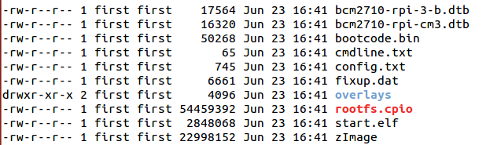
Those files need to be on the FAT 32 first partition on the sd card
using gparted I created a large fat32 partition and copy using cp -r.
and Does the Linux will boot and work with initramfs?

Yes!!
Linux is booted and stayed in ramfs.

I have created a second partition in the sdcard for ext4 file system as empty.
And now I can stored all persistence on that ext4 partition.

Every module that we will add in build root will be located in ram fs.

In order to build and copy on the sdcard we need to compile and copy in the Ubuntu.
For examples
QT , node js should be located on the sdcard and not on memory.

But this is a different story.
For now, we can return back to rootfs.

The next step is to build a Linux from scratch that build the same image, because some important steps were hide from us by buildroot.

